A MAPPING APPROACH TO PHANTOM GRAPHS.

Consider the basic parabola y = x² drawn on simple x, y axes.
When we plot points we choose x values and calculate corresponding y values.

x = 1 so y = 1² = 1 then plot (1, 1)
x = 2 so y = 2² = 4 then plot (2, 4)
as shown below.

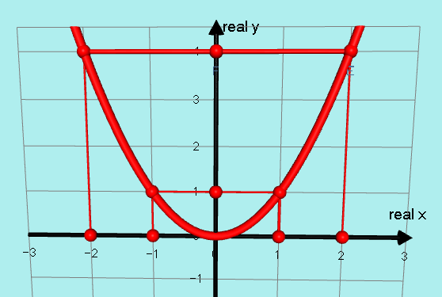

I want to think of this as mapping x values from an x axis onto y values on a parallel y axis as below:
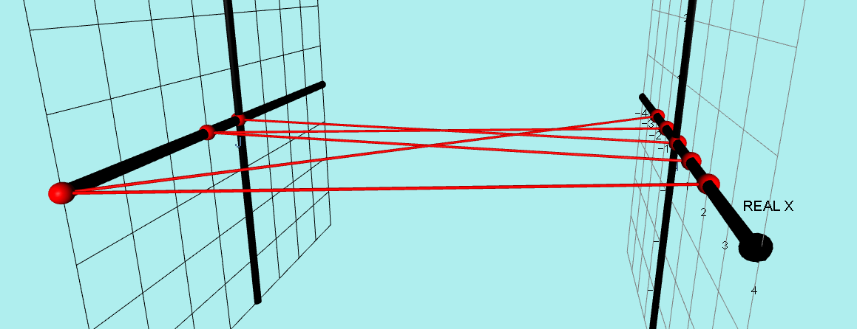
1
2
3
4
REAL Y

Obviously, positive and negative x values map onto only positive y values.
I will show this by colouring the whole x axis RED but only the positive y axis 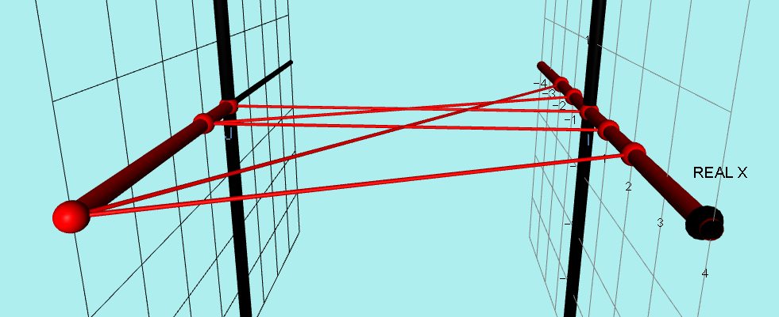
1
2
3
4
REAL Y

Of course the basis of phantom graphs is that some complex x values do produce real y values when substituted in the graph’s equation.
In this case, if x = i then y = i² = – 1 and if x = 2i then y = i² = – 4 as below:

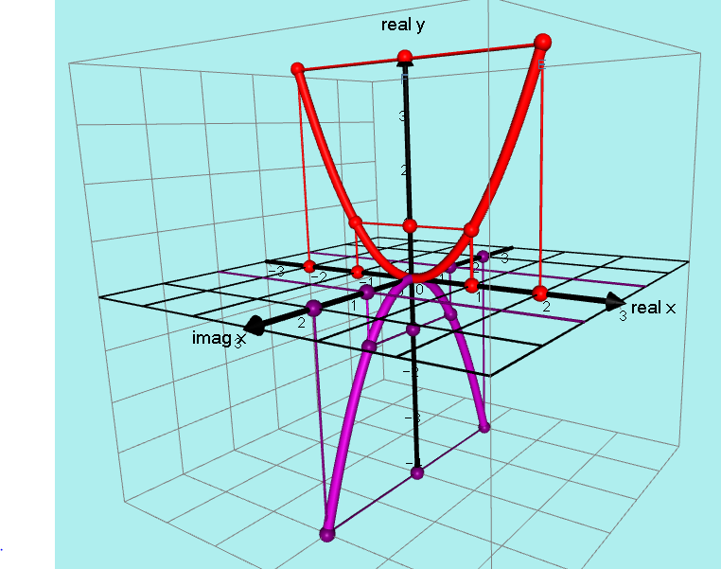
The REAL points are RED and the IMAGINARY points are PURPLE.

To demonstrate this as a mapping process, we need an x plane mapping onto just a y axis.

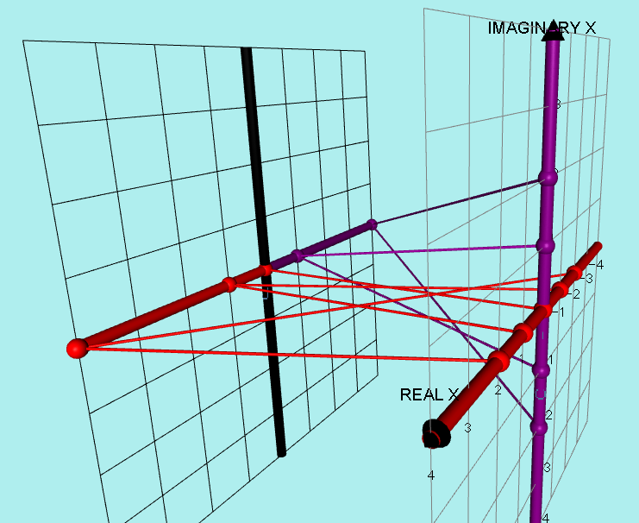
REAL Y
IMAGINARY Y
-4
-3
-2
-1
1
2
3
4

Notice that the whole REAL x axis maps onto only the positive y values and
the whole IMAGINARY x axis maps onto only the negative y values.
________________________________________________________

Now we come to a whole new stage where we consider what happens to the other complex x values when we substitute them into the equation y = x²

Just as both x = 2 and x = – 2 map onto y = +4 and x = 2i and
x = – 2i both map onto y = – 4, the same thing happens with pairs of complex x values. They occur in pairs.

x = 1 + i maps onto y = (1 + i)² = 2i
x = –1 – i maps onto y = (–1 – i)² = 2i
x = 2 + i maps onto y = (2 + i)² = 3 + 4i
x = –2 – i maps onto y = (–2 – i)² = 3 + 4i

x = 1 + 2i maps onto y = (1 + 2i)² = –3 + 4i
x = –1 – 2i maps onto y = (–1 – 2i)² = –3 + 4i

x = 1 – i maps onto y = (1 – i)² = –2i
x = –1 + i maps onto y = (–1 + i)² = –2i

x = 1 – 2i maps onto y = (1 – 2i)² = –3 – 4i
x = –1 + 2i maps onto y = (–1 + 2i)² = –3 – 4i

x = 2 – i maps onto y = (2 – i)² = 3 – 4i
x = –2 + i maps onto y = (–2 + i)² = 3 – 4i

I have put these points on as GREEN DOTS AND LINES.
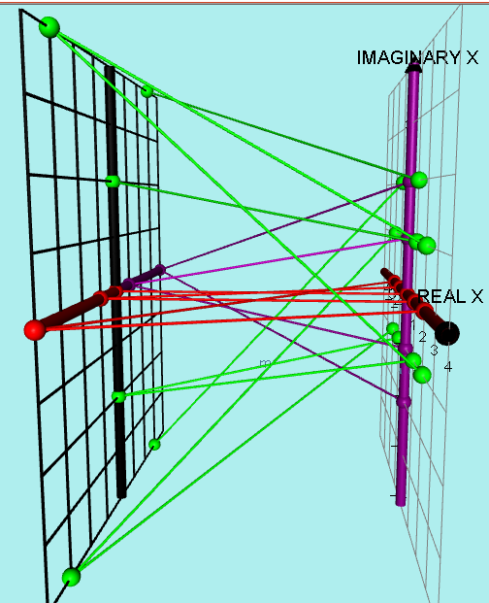
To make this a little bit clearer I will take off the red and purple lines and dots.
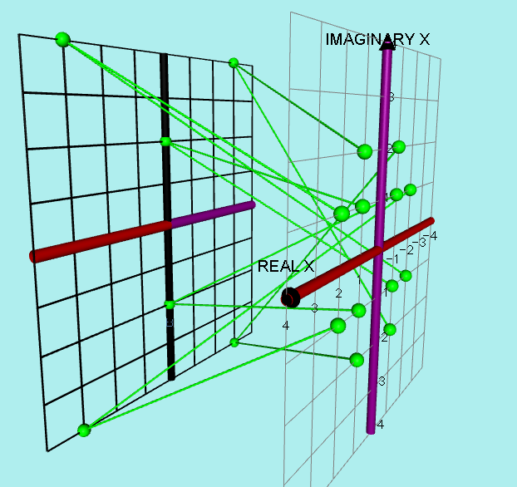
(–3, + 4i)
(3, + 4i)
(3, – 4i)
REAL Y
IMAGINARY Y
Notice that the 12 points chosen
on the complex x plane only
mapped onto 6 points on the
complex y plane.

At this stage there does not seem to be a clear pattern forming from these complex y points.
I decided to add just a few more:
x = ½ + ½ i maps onto y = (½ + ½ i)² = 0 + i
x = –½ – ½ i maps onto y = (–½ – ½ i)² = 0 + i

x = –½ + ½ i maps onto y = (–½ + ½ i)² = 0 – i
x = +½ – ½ i maps onto y = (+½ – ½ i)² = 0 – i
The above 4 point are coloured a darker green.
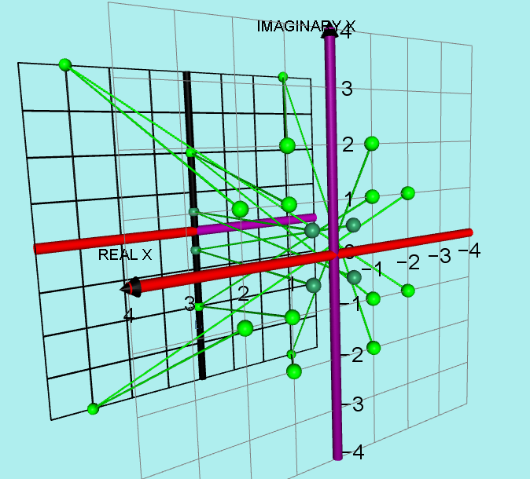
IMAGINARY Y
REAL Y

It should be noted that, for example, if x = 2 + i then y = 3 + 4i
so we would need two dimensions to plot x = 2 + i as (2, 1) and two further dimensions to plot y = 3 + 4i as (3, 4) which of course implies FOUR DIMENSIONAL SPACE so the above mapping cannot be represented as an actual 4D “curve” or “surface” since we can only function in 3D space.

However, I did find some surprising patterns when mapping sets of linear points on the complex x plane onto the complex y plane!

MAPPING SHOWING HOW POINTS IN THE COMPLEX X PLANE OF THE FORM a ± 1i MAP ONTO THE COMPLEX Y PLANE AFTER y = x²

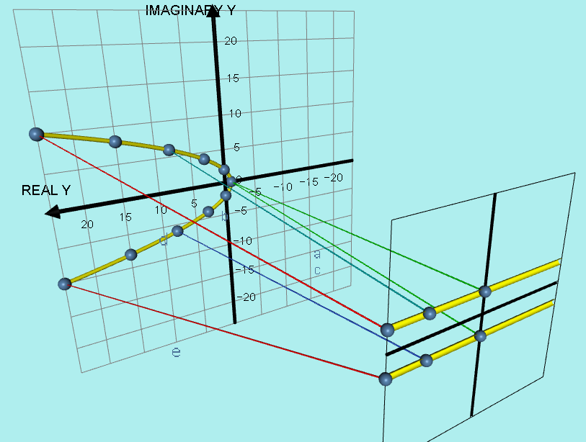
1i

–1i
y = 24 +10i
y = 24 – 10i
x = 5 – i x = 3 – i x = 0 - i
IMAG x
Real x

I used complex x values in the form of ± a ± 1i as shown by the yellow lines above on the complex x plane and transformed them using the equation y = x²
onto a complex y plane.

As you can see the result was complex y values forming the parabola, given by the equation y = t² – 1 using t as the variable for the imaginary y coordinates.
4
______________________________________________________________

I decided to repeat the investigation for complex x values in the forms

x = ± a ± 2i and x = ± a ± 3i

In each case, keeping the imaginary part constant and varying the real part.

MAPPING SHOWING HOW POINTS IN THE COMPLEX X PLANE OF THE FORM a ± 2i MAP ONTO THE COMPLEX Y PLANE AFTER y = x²

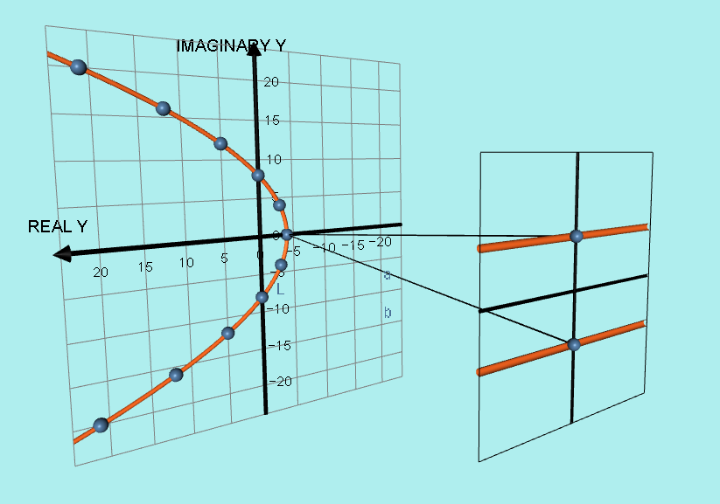
2i

– 2i
Imag x
Real x

This time the equation of the parabola formed was y = t² – 4
16

MAPPING SHOWING HOW POINTS IN THE COMPLEX X PLANE OF THE FORM a ± 3i MAP ONTO THE COMPLEX Y PLANE AFTER y = x²

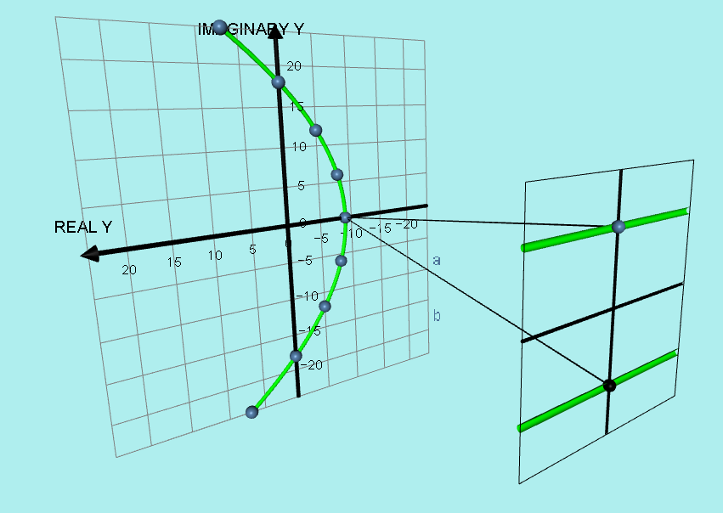
3i

– 3i
Real x
Imag x

This time the equation of the parabola formed was y = t² – 9
36

Next I decided to transform numbers of the form x = (1 + bi)
Keeping the real part constant and varying the imaginary part.

MAPPING SHOWING HOW POINTS IN THE COMPLEX X PLANE OF THE FORM 1 ± 1i MAP ONTO THE COMPLEX Y PLANE AFTER y = x²

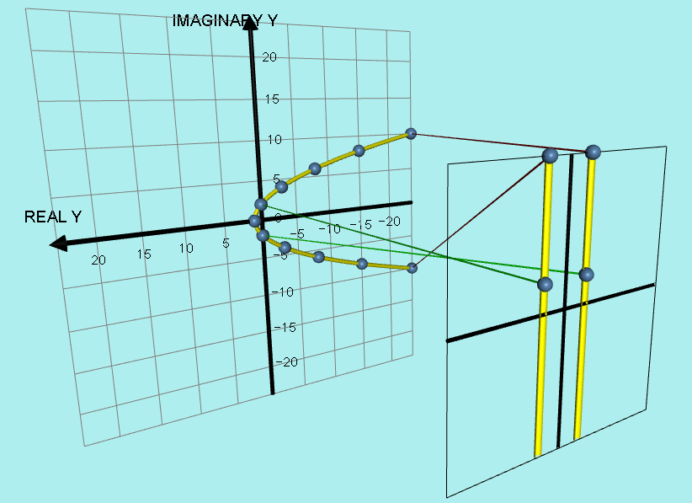
–1
1
Imag x
Real x

This is just a reflection of the transformation of x values of the form a + 1i

The parabola of complex y values has the equation y = – t² + 1
4

MAPPING SHOWING HOW POINTS IN THE COMPLEX X PLANE OF THE FORM 1 ± 2i MAP ONTO THE COMPLEX Y PLANE AFTER y = x²

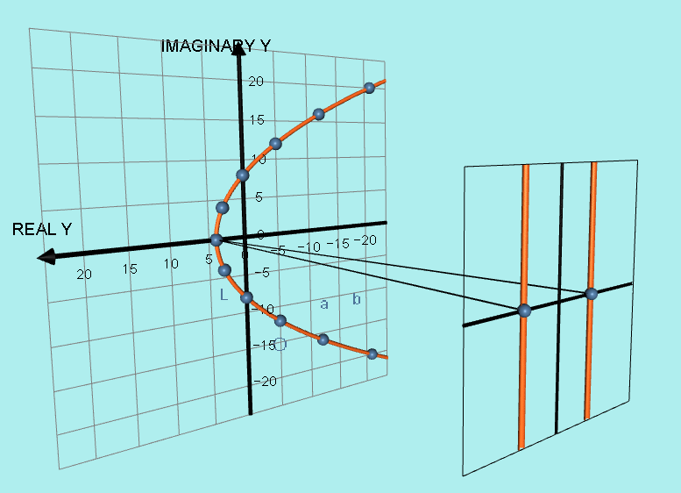
–2
2
Imag x
Real x

This is just a reflection of the transformation of x values of the form a + 2i

The parabola of complex y values has the equation y = – t² + 4
16

MAPPING SHOWING HOW POINTS IN THE COMPLEX X PLANE OF THE FORM 1 ± 3i MAP ONTO THE COMPLEX Y PLANE AFTER y = x²

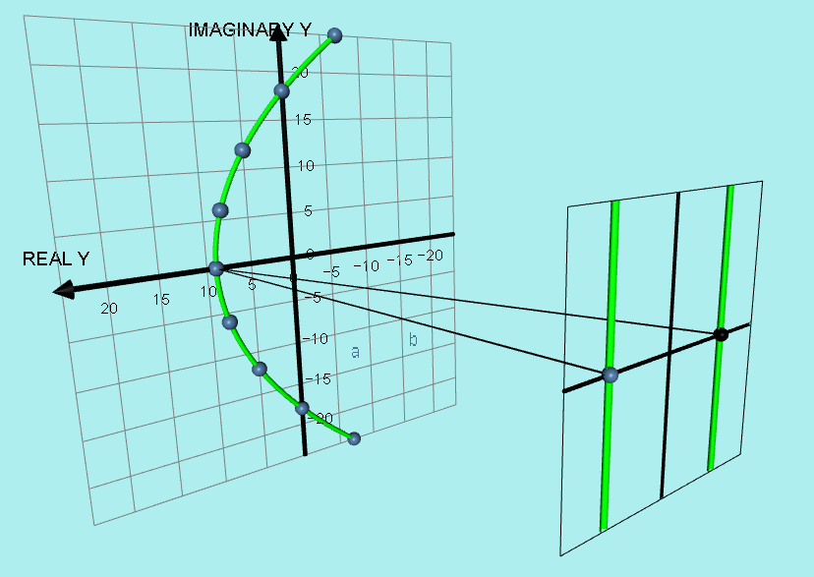
3
–3
Imag x
Real x

This is just a reflection of the transformation of x values of the form a + 3i

The parabola of complex y values has the equation y = – t² + 9
36

One final interesting point is that if I transform x = 0 + bi all the points become totally REAL on the complex y plane which is the very basic form of phantom graphs!

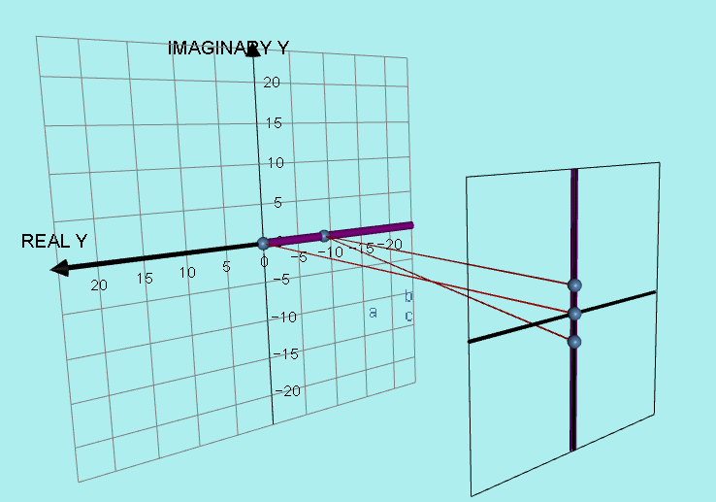
3

–3
Imag x
Real x

